Real-Time Audio Spectrum Analyzer on STM32F401
@pranav
Group 2: J Harshith (CB.SC.U4CSE24721) · Jason Richards (CB.SC.U4CSE24722) · Pranav Machireddy (CB.SC.U4CSE24730) · Rajeev Lochan (CB.SC.U4CSE24731)

Abstract
This project is a real-time audio spectrum analyzer built on an STM32F401 Black Pill, programmed at register level with CMSIS in Keil uVision 5 (no HAL). A MAX4466 microphone is sampled at 16 kHz by a timer-triggered 12-bit ADC. Each 512-sample block (32 ms) is windowed with a Hann window and passed through a 512-point FFT. The result is drawn as 32 log-spaced bars (31 Hz to 8 kHz) on an ILI9341 TFT over SPI, with peak frequency and level shown. The same data is sent every 250 ms to a phone through an HC-05 Bluetooth module, and three buttons, three LEDs and phone commands control the display.

1. Introduction and objectives
A spectrum analyzer shows which frequencies are present in a sound and how strong each one is. Instruments like this usually need a PC or costly equipment. This project builds a standalone one on a low-cost microcontroller, using the Cortex-M4F's floating-point unit to run a Fast Fourier Transform (FFT) in real time.
The objectives were:
- Capture audio at a steady 16 kHz using a timer-triggered ADC.
- Analyse each block with a 512-point FFT to get the frequency content.
- Display 32 log-spaced bars on a TFT, with the peak frequency and level.
- Stream and control over Bluetooth, so a phone can receive the data and send commands.
- Use register-level CMSIS code in Keil uVision 5, with no HAL, to show how the peripherals work.

2. Hardware components
The whole system is built on a breadboard from the parts below.
Component | Role in the project | Why it was chosen
STM32F401 Black Pill | Main controller, 84 MHz Cortex-M4F with FPU | Fast enough for a 512-point FFT every 32 ms
MAX4466 microphone module | Picks up sound and amplifies it (adjustable gain) | Clean analog signal for the ADC
ILI9341 TFT, 2.4 / 2.8 in, SPI | Shows the bars, peak frequency and level | 320 x 240 colour, fast SPI interface
HC-05 Bluetooth module | Serial link to a phone at 9600 baud | Simple UART interface, easy to pair
3 push buttons | Mode, pause and grid control | Direct user control
3 LEDs with 220 ohm resistors | Red = loud, green = heartbeat, blue = grid on | Visible status
Capacitors | Supply decoupling | Reduce noise on the mic signal
ST-Link V2 | Programs and debugs the board | Works directly with Keil uVision
Breadboard and jumper wires | Connections | Quick prototyping
Pin summary
Signal | Pin
Microphone output | PA1 (ADC1 channel 1)
HC-05 TX / RX | PA10 / PA9 (USART1)
HC-05 STATE | PB15
Buttons: mode, pause, grid | PB12, PB13, PB14
LEDs: red, green, blue | PB7, PB8, PB9
On-board LED (paused) | PC13
TFT | SPI1 at 10.5 MHz

3. System design
The design is shown in four diagrams: how the blocks connect, the circuit, the firmware flow and the system states.
3.1 Block diagram. The microphone feeds the ADC. The FFT runs on the Cortex-M4F. Results go to the TFT over SPI1 and to the phone over USART1.
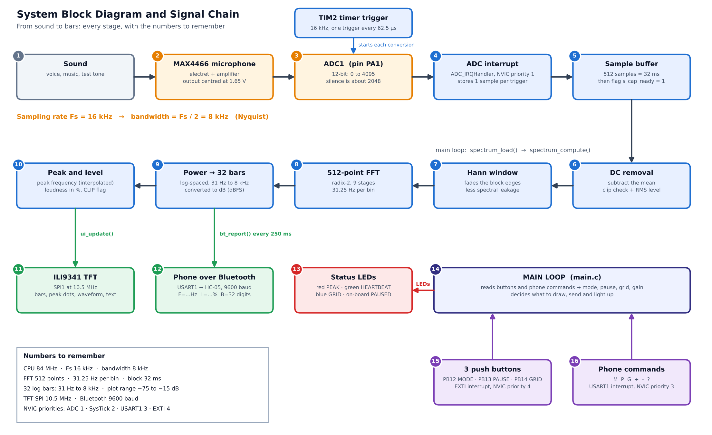
3.2 Circuit schematic. The mic output goes to PA1. The HC-05 uses USART1. The TFT uses SPI1. Buttons and LEDs sit on GPIOB, each LED through a 220 ohm resistor.
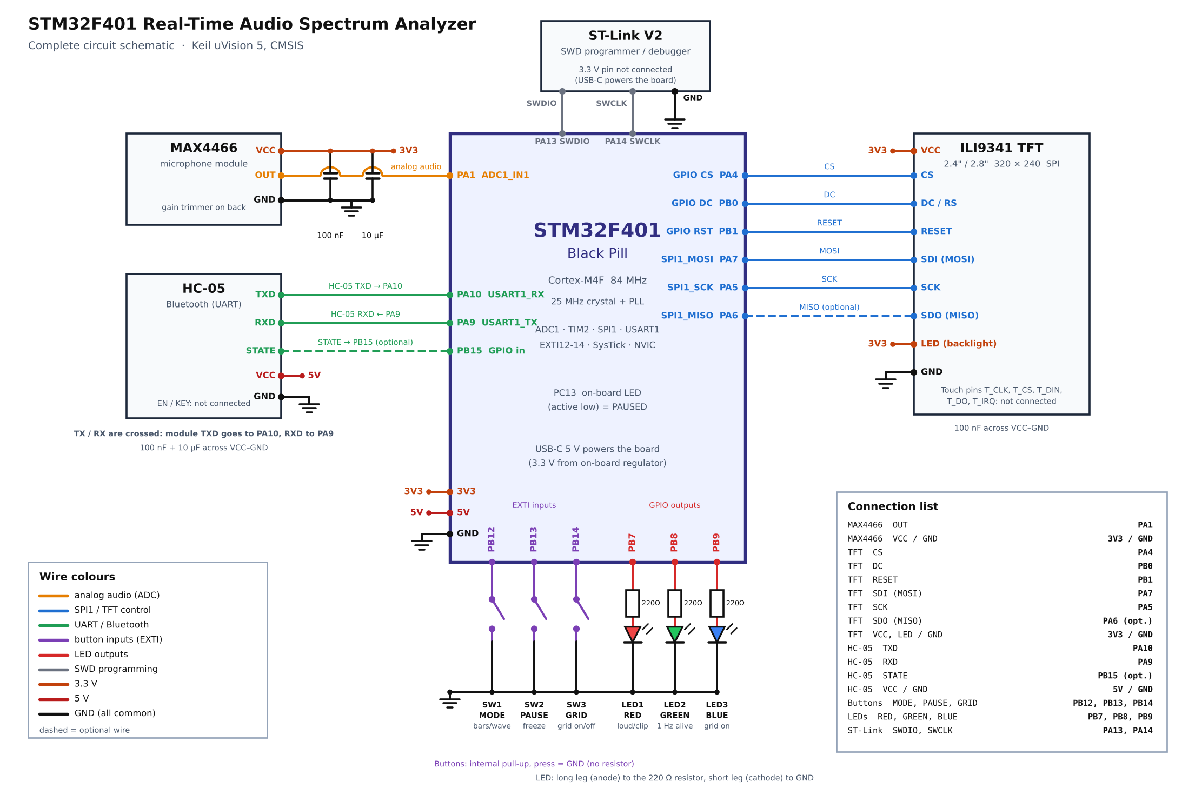
3.3 Firmware flowchart. After initialisation the main loop waits for a full 512-sample block, then runs the FFT, redraws the display, polls buttons and sends the Bluetooth report.
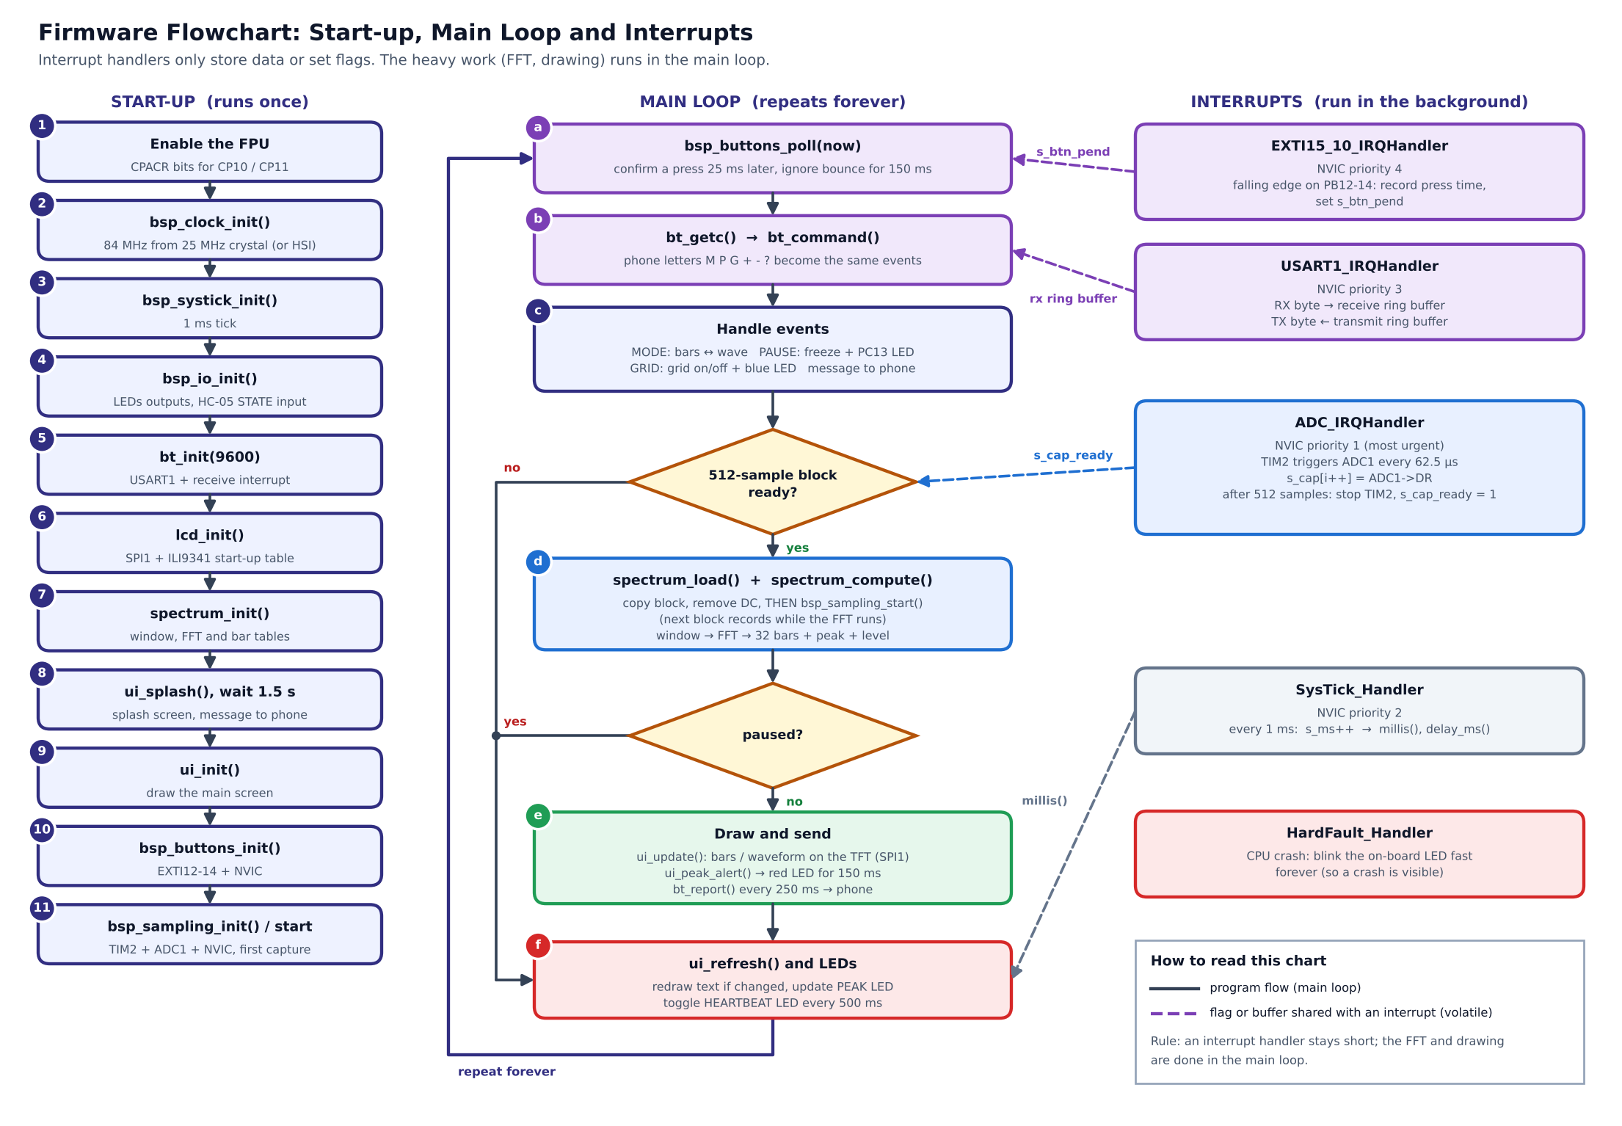
3.4 State diagram. After reset and initialisation the system stays in one ACTIVE state. Six regions work side by side: display mode, run or pause, grid, loud level, Bluetooth link and gain.
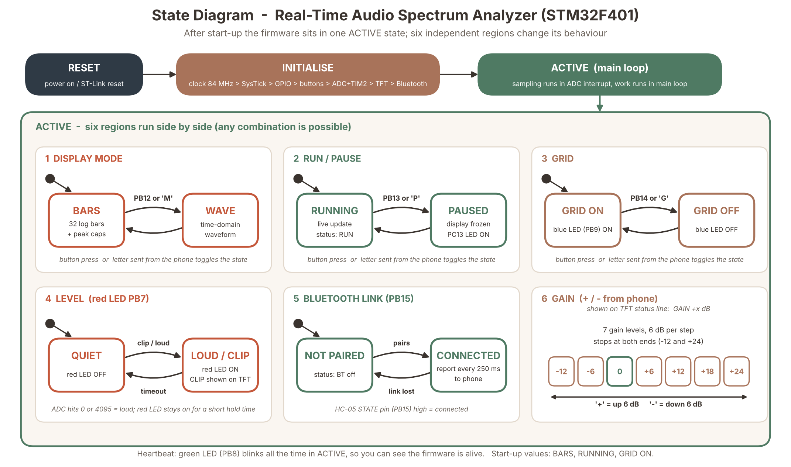
3.5 Tools used: Keil uVision 5 (editor, compiler, debugger), CMSIS device headers for register access, and an ST-Link V2 for flashing and debugging.

4. Working principle
Sound becomes bars in five steps.
- Clock. A 25 MHz crystal feeds the PLL (M=25, N=336, P=4) to give an 84 MHz system clock. If the crystal fails, the internal 16 MHz oscillator is used instead.
- Sampling. TIM2 (ARR = 5249) overflows at 16 kHz and triggers ADC1 through TRGO. The 12-bit ADC reads channel 1 (PA1) with 84-cycle sampling at a 21 MHz ADC clock. Timer triggering gives exactly equal sample spacing.
- Block collection. Each ADC end-of-conversion interrupt stores one sample. After 512 samples (32 ms) the main loop is told a block is ready.
- Processing. The average is subtracted (DC removal), a Hann window is applied, and a 512-point radix-2 FFT is computed.
- Bars. FFT magnitudes are grouped into 32 log-spaced bars from 31 Hz to 8 kHz. The level is given in dBFS. The peak frequency is refined by parabolic interpolation.
Key figures
Quantity | Value | How it comes about
Sample rate | 16 kHz | 84 MHz / 5250
Bandwidth | 8 kHz | Nyquist: sample rate / 2
FFT size | 512 points | Chosen for resolution and speed
Bin width | 31.25 Hz | 16000 / 512
Block time | 32 ms | 512 / 16000
Bars | 32 | Log-spaced, 31 Hz to 8 kHz
Log spacing gives the low notes more bars, as the ear does. The Hann window reduces spectral leakage. DC removal stops the microphone's bias voltage hiding real signals.

5. Firmware
The firmware is one main.c of about 1,800 lines. Interrupt handlers stay short and only collect data or set flags; the main loop does the heavy work. This keeps sampling free of gaps.
Interrupts
Handler | Priority | Job
ADC_IRQHandler | 1 | Stores each sample, flags a full 512-sample block
SysTick_Handler | 2 | 1 ms tick for timing, blinking and debouncing
USART1_IRQHandler | 3 | Moves Bluetooth bytes through ring buffers
EXTI15_10_IRQHandler | 4 | Records a button edge for later debouncing
Main functions
Group | Functions | Purpose
Setup | bsp_clock_init, bsp_systick_init, bsp_io_init, bsp_buttons_init, bsp_sampling_init | Clock, tick, pins, buttons, TIM2 and ADC
Display | lcd_init, lcd_set_window, lcd_push_color, gfx_, ui_ | Drive the ILI9341 over SPI and draw bars, text and grid
Bluetooth | bt_init, bt_putc, bt_puts, bt_put_uint, bt_getc | Ring-buffered UART link to the HC-05
Processing | spectrum_init, spectrum_load, spectrum_fft, spectrum_compute | Window, FFT, bars, level and peak
Control | bsp_buttons_poll, led_set | Debounced buttons and status LEDs
Entry | main | Initialise, then loop forever
Display. SPI1 runs at 10.5 MHz. Only bars that changed are repainted, because a full redraw takes about 117 ms. Bars are green when low, yellow when mid and red when high, with falling peak caps.
Buttons. An input must stay stable for 25 ms and then a 150 ms lockout follows, so one press is counted once.
Bluetooth. The HC-05 runs at 9600 baud. A report goes to the phone every 250 ms. Commands: M mode, P pause, G grid, + and - gain (6 dB steps from -12 to +24 dB), ? help.
Main loop order: wait for a block, run the FFT, redraw, poll buttons, handle Bluetooth input, send the report, update the LEDs.

6. Implementation and results
The system was built and tested on a breadboard. It was recorded working, with live bars on the TFT and spectrum reports on a phone Bluetooth terminal.
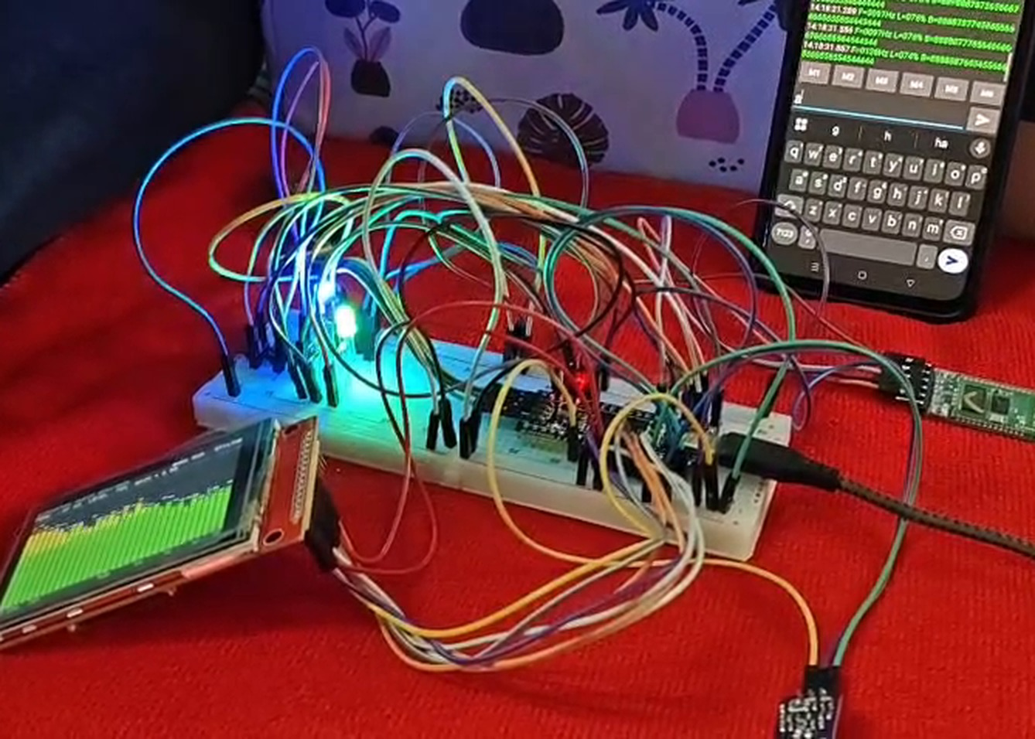
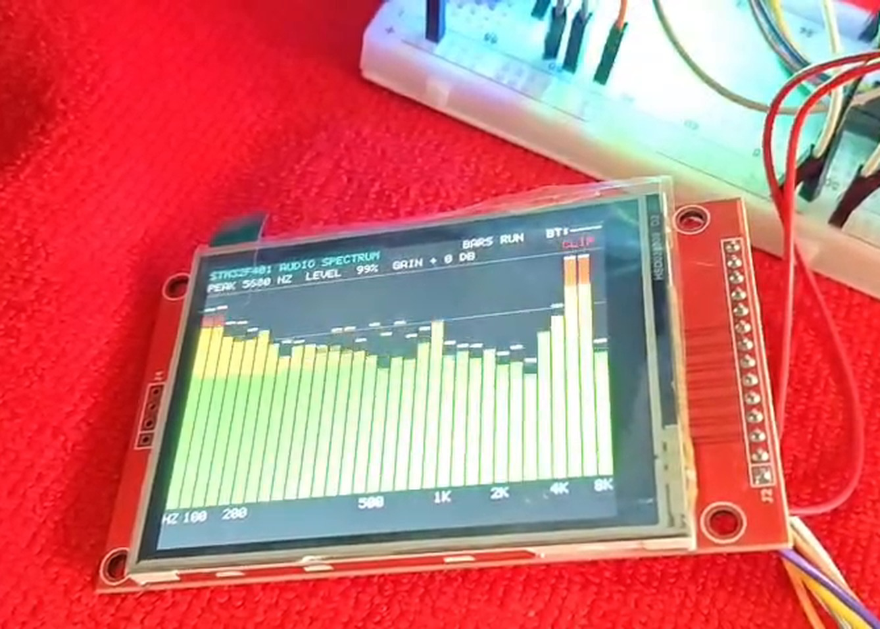
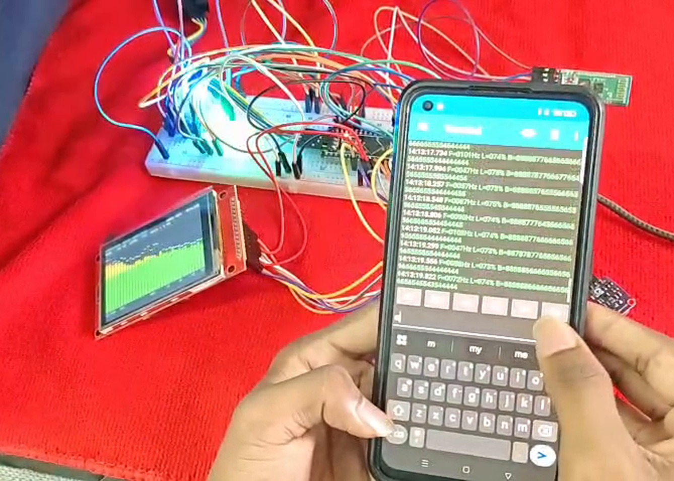
Feature | Observed result
Spectrum bars | Move with sound; changes show at the matching frequency
Peak and level readout | Shown on the TFT status line
Mode button | Switches bars and waveform
Pause button | Freezes the display; on-board LED lights
Grid button | Toggles grid lines; blue LED follows
Red LED | Lights on loud sound
Bluetooth | Phone receives reports and commands work
A demo video of the working system was recorded and is available with the project source code.

7. Conclusion and future scope
The project shows that a low-cost STM32F401 can capture, analyse and display audio spectra in real time. Timer-triggered sampling at 16 kHz gives an 8 kHz bandwidth, and a 512-point FFT gives 31.25 Hz resolution. Short interrupts and a work-in-main-loop design keep sampling free of gaps, and the TFT and Bluetooth outputs both work. Writing it at register level with CMSIS gave a clear view of the clock, timer, ADC, SPI, UART and NVIC peripherals.
Future scope
- Use DMA for sampling to free the CPU.
- Raise the sample rate for a wider bandwidth.
- Use a larger FFT for finer resolution.
- Save spectra to an SD card.
- Add touch-screen controls on the TFT.

References
- STMicroelectronics, RM0368 Reference manual: STM32F401xB/C and STM32F401xD/E.
- STMicroelectronics, STM32F401 datasheet.
- ARM, CMSIS documentation and Cortex-M4 Technical Reference Manual.
- Maxim Integrated, MAX4466 datasheet.
- Ilitek, ILI9341 TFT controller datasheet.
- ITead Studio, HC-05 Bluetooth module datasheet.

